2025 Panthers Boys & Girls Soccer Camp

(Incoming 1st –5th Graders)
-------------------------------
Monday, June 9th – Wednesday, June 11th
8:30am-11:30am, Paschal Turf Field @ Paschal HS
-------------------------------
Designed for All Levels Beginner to Advanced
- What to wear? – Soccer shorts and top, shin guards, shoes or cleats
- What to bring? – Soccer ball, sunscreen, goalkeepers bring gloves if you own a pair, water jug or bottle (there will be a refill station!)
- Cost – $150 for camp (Paschal Soccer Camp Shirt included- wear on the last day!)
- First Day – Arrive at 8am for orientation and check-in!
- Last Day – Closing Award Ceremony with players & parents, 11:15-11:30am
- Contact Coach Stallcup or Coach Haro with any questions or additional information – alyson.stallcup@fwisd.org & michael.haro@fwisd.org
- Registration Deadline: Friday, May 30th, payments can be made on the first day of camp!

This camp will focus on developing individual skill in all areas of the game with emphasis on ball mastery and beginning move sets. Campers will learn and train in small groups based on their appropriate skill level. The focus of this camp will be on individual development, along with ample competitions to challenge oneself. The players will leave camp with a wealth of experience to continue to train and improve on their own and with their local teams. Players will learn more about the game and become better players while at the same time having fun!

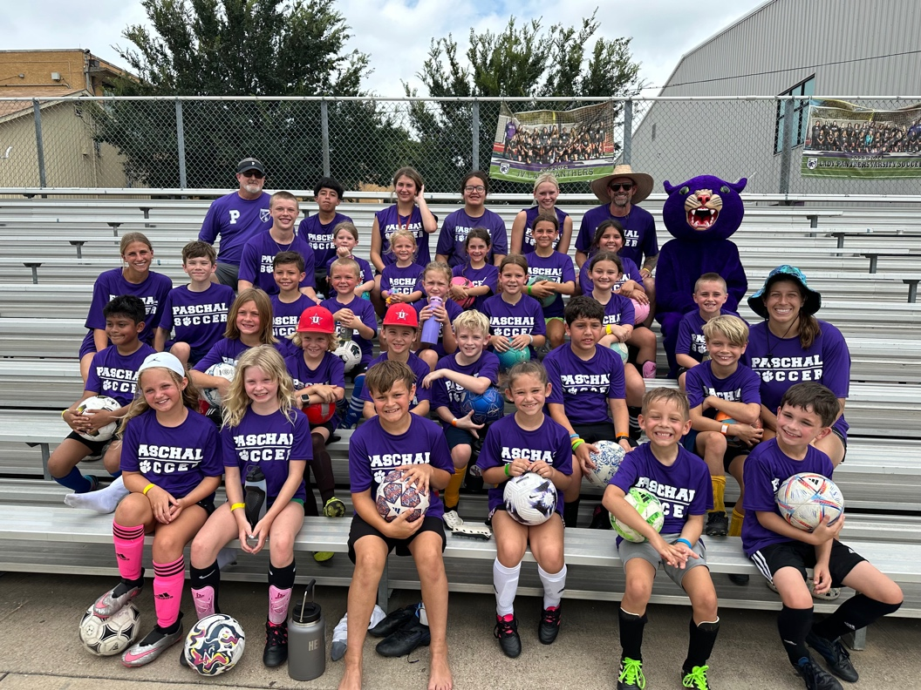
QR Code for Camp Registration


QR Code for FWISD Payment Option


